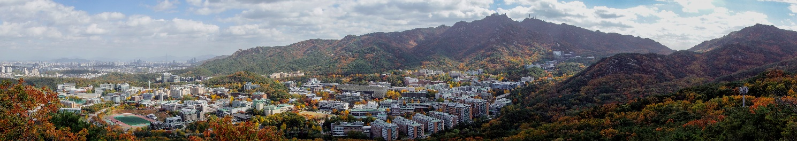

**ICASP13**

**13th International Conference on Applications of Statistics and Probability in Civil Engineering**

**May 26-30, 2019 | Seoul, South Korea**

### **REQUEST FOR RESERVATION AT ON-CAMPUS ACCOMODATION**

In order to request for a reservation at the on-campus accommodation – [Hoam Faculty House](http://www.hoam.ac.kr/eng/), please complete this form and return directly to the Conference Secretariat of ICASP13 at [registration@icasp13.org](mailto:registration@icasp13.org) until February 28, 2019. Please note that the request is valid only if the “Registration No.” from your online registration is provided in this form. The secretariat will respond to the request in a few days to confirm if the request can be fulfilled. Bookings can be closed early due to the limited availability.

**▪ Personal Information**

|  |  |  |  |
| --- | --- | --- | --- |
| **Title** | □ Prof. □ Dr. □ Mr. □ Ms. | **Registration No.(Required)** |  |
| **Last Name** |  | **First Name** |  |
| **Affiliation** |  | | |
| **Address** |  | | |
| **Phone No.** |  | **E-mail** |  |

**▪ Room Details (Unit: KRW)**

|  |  |  |  |  |  |  |  |  |
| --- | --- | --- | --- | --- | --- | --- | --- | --- |
| **Hotel** | **Room Type (Bed type/Occupancy)** | | | **Special Rate**  **(including taxes and fees)** | | **Priority (“O” at your 1st, 2nd and 3rd choices)** | | |
| **1st** | **2nd** | **3rd** |
| [**HOAM FACULTY HOUSE**](http://www.hoam.ac.kr/eng/)  (Seoul National University)  * 25 min. walking distance from the conference venue | Standard | [Double Bed Room](http://www.hoam.ac.kr/eng/rooms/standard.php?gu=1&gu2=standard) (1 DBL / 1~2 person) | | 94,050 | |  |  |  |
| [Twin Bed Room](http://www.hoam.ac.kr/eng/rooms/standard.php?gu=2&gu2=standard) (2 SGL / 1~2 person) | | 94,050 | |  |  |  |
| [Triple Bed Room](http://www.hoam.ac.kr/eng/rooms/standard.php?gu=3&gu2=standard) (1 DBL+1 SGL / 1~3 person) | | 108,900 | |  |  |  |
| [Korean Style Ondol Triple](http://www.hoam.ac.kr/eng/rooms/standard.php?gu=5&gu2=standard) (Ondol / 1~3 person) | | 108,900 | |  |  |  |
| Deluxe | [Double](http://www.hoam.ac.kr/eng/rooms/deluxe.php?gu=1&gu2=deluxe) (1 DBL / 1~2 person) | | 133,650 | |  |  |  |
| [Twin](http://www.hoam.ac.kr/eng/rooms/deluxe.php?gu=2&gu2=deluxe) (2 SGL / 1~2 person) | | 133,650 | |  |  |  |
| Residence | [Suite with 2 rooms - suitable for the family](http://www.hoam.ac.kr/rooms/residence.php?gu=2&gu2=residence)  (1 DBL + 1 Korean style ondol room / 1~4 person) | | 198,000 | |  |  |  |
| **Date** | Check-in | **May/DD/2019** | Check-out | | **May/DD/2019** | | | |
| **No. of Guests** | □ 1 □ 2 □ 3 □ 4 □ 5  *\** ***Note:*** *For “Standard” and “Residence” type rooms, one more guest than the occupancy limit shown in the list above can be accommodated with the additional charge of 16,500 KRW.* | | | | | | | |
| **Special Request** |  | | | | | | | |
| **Note** | *\* The above rooms and rates are available from May/25/2019 to May/31/2019 only.*  *\* Details about the rooms will be shown when you click the corresponding hyperlinks above.*  *\* Check-in time - 2:00 pm, Check-out time - 11:00 am (Local time).*  *\* Breakfast is not included, but available for 12,000 KRW, please pay at the property.*  *\* Special requests are not guaranteed.* | | | | | | | |

**▪ Payment Details**

|  |  |  |  |
| --- | --- | --- | --- |
| **Payment Method** | □ Amex □ Diners □ Master □ Visa □ JCB | | |
| **Card Number** |  | **Expiry Date** | **MM/YY** |
| **Card Holder’s Name** |  | **3-digit Security Code** (Amex: 4-digit) |  |
| ***Note :*** *We require a valid credit card (debit cards are not accepted) in order to guarantee and confirm your booking. Your card will not be charged unless you cancel your booking after the allotted time. Please pay at the Hotel.* | | | |

**▪ Cancellation Policy**

|  |
| --- |
| □ I agree to the below cancellation policy. |
| *\* 50% of one night room rate for any cancellation made than 3 days prior to the scheduled arrival.*  *\* 70% of one night room rate for any cancellation made than 2 days prior to the scheduled arrival.*  *\* 100% of one night room rate will be levied for any cancellation made less than 1 day prior to the scheduled arrival.*  *This will be applied for no show.* |

|  |  |  |  |
| --- | --- | --- | --- |
| *Date* |  | *Signature* |  |